Bartagamen

Team 2 Bartagamenmenschen

Bryce, Janik, Race

**Software Requirements Specification**

**Document**

**Version: (2)** **Date: (05/18/2022)**

**Table of Contents**

1 Purpose 3

2 Scope 3

3 User characteristics 3

3.1 Key users 3

3.2 Secondary users 3

3.3 Unimportant users 4

4 Product perspective 4

4.1 System Context 4

4.2 User interfaces 4

4.3 Software interfaces 5

4.4 Deployment requirements 5

5 Assumptions and Dependencies 5

6 Specific requirements 5

6.1 System Functional Requirements 5

6.2 Logical Database Requirements 6

6.3 Software System Attributes 6

6.3.1 Usability 6

6.3.2 Performance 6

6.3.3 Reliability/Dependability 6

6.3.4 Maintainability 6

# 1 Purpose

Bearded dragons are a class of pet that fall under the category of exotic species. Unlike dogs or cats, the care requirements for these pets tends to suffer from poor documentation, misinformation, information disputes, and an overall lack of knowledge. Perhaps the biggest challenge for a bearded dragon owner is diet since bearded dragons are omnivores and many different types of food must be incorporated into their diet. It can be daunting for a bearded dragon owner to comb through the list of approved foods and put together an adequate diet based on veterinary guidelines. This is the target market for this application.

There is no existing meal plan software for bearded dragons. The tools to easily fill this niche are effectively non-existent. Planning a sufficiently balanced diet to maintain proper health can be difficult even for the most experienced owner. This tool can help every owner regardless of experience improve the nutritional wellbeing of their pet.

# 2 Scope

This is a local application that maintains a list of safe foods for bearded dragons. In addition to having a complete list of approved foods for the pet, the application will provide a breakdown of the best available dietary information for the pet based on its age. This will include tracking of various dietary restrictions on a timeline suitable for these pets, providing owners of bearded dragons a flexible and powerful tool to help maintain proper nutrition throughout the full lifecycle. The dietary needs of these pets changes with age and other unique factors for each pet. By empowering the owners of these pets, this application will help maintain healthier pets, and more positive ownership experiences for our users.

This application will allow the user to follow a meal plan and supplement schedule, edit the list of approved foods or generated meal plans to account for bearded dragon / owner preferences or local availability of certain food items, and read any extra information corresponding with bearded dragons, prioritize planning the diet of your bearded dragon while tracking restrictions on a monthly calendar.

# 3 User characteristics

The primary use group for this application is comprised of pet owners of bearded dragons. This is designed to be useful to both novices and expert owners in tracking the requirements to maintain positive dietary health for this breed of exotic pet.

## 3.1 Key users

**Hobbyist**: Possesses moderate knowledge of owning a bearded dragon and providing the diet required for its care. The app will focus on providing any tips to help the bearded dragon, which will benefit their health and companionship with the owner.

## 3.2 Secondary users

**Novice**: First time pet owners of a bearded dragon, possess little to no prior knowledge of how to care for a bearded dragon. Provide a general overview as well as a deeper insight to what may benefit the bearded dragon.

## 3.3 Unimportant users

**Master**: Professional experts and/or long time enthusiasts that are interested in recording data of the reptiles diet and potentially maintaining better records.

# 4 Product perspective

## 4.1 System Context

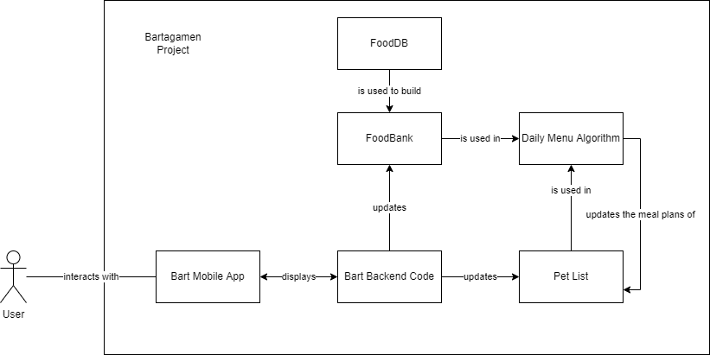

## 4.2 User interfaces

[SRS:UX:1] The application shall support mobile phones in a portrait orientation.

[SRS:UX:2] The application shall have a constant navigation bar at the bottom of the screen.

[SRS:UX:3] The navigation bar shall have buttons that redirect to the Home Screen, Pet List Screen, and the Food Bank.

[SRS:UX:4] The Pet List Screen shall auto highlight the day based on current mobile calendar info.

[SRS:UX:5] The application shall display a list of pets managed by the user.

[SRS:UX:6] The application shall display the menu plan for any lizard in the pet list.

[SRS:UX:7] The application shall display the monthly view of a menu plan for any lizard in the pet list

[SRS:UX:8] The application shall allow the user to see the meal plan for a lizard for each day in the week

## 4.3 Software interfaces

We are depending on the Android mobile operating system.

## 4.4 Deployment requirements

Android OS running on a smart phone is the only requirement. Data tables will be created and populated by the application and do not need to be handled by the user.

# 5 Assumptions and Dependencies

The user is on an Android smartphone. The user is an owner of or familiar with lizards and their diets. The user reads and understands English. The user has access to a grocery store.

# 6 Specific requirements

## 6.1 System Functional Requirements

[SRS:FX:1] As a user I want to see a generated daily meal plan for a list of bearded dragons based on multiple factors, referred to as The Daily Menu Algorithm (DMA), so that I have a quick look what my dragons should eat.

[SRS:FX:2] As I user I get a daily meal plan which considers pet size, age, and items currently in the user food bank when deciding the daily meal plan, so that a balanced meal plan will be created.

[SRS:FX:3] As a user I am able to fill the database with available foods, so that the DMA can create a meal.

[SRS:FX:4] As a user I shall be able to modify the portions they have in stock of items in the food bank.

[SRS:FX:5] As a user I shall be able to remove items from the food bank

[SRS:FX:6] As a user I shall be able to add pets to the pet list, so that I am able to manage all my pets.

[SRS:FX:7] The user shall be able to edit attributes of pets in the pet list

[SRS:FX:8] As a user I should be allowed to scroll between months when in the monthly view.

[SRS:FX:9] As a user I should be allowed to switch between pets when viewing their daily meal plan, so that I see the meal plans separately.

[SRS:FX:10] As a user I should be able to see the total sum of food portions needed for the day.

## 6.2 Logical Database Requirements

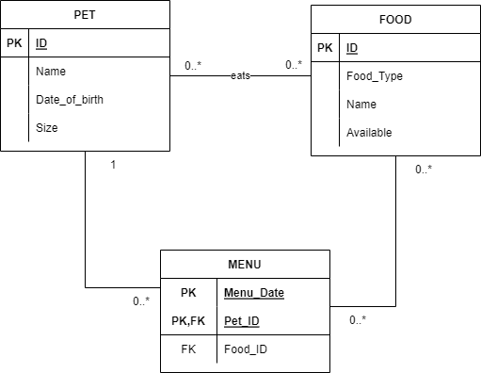

## 6.3 Software System Attributes

### 6.3.1 Usability

The application will be as responsive when switching screens, pressing buttons, as the average application installed from the Google play store.

### 6.3.2 Performance

There is no limit on the number of supported users, everything is handled locally.

The app will support up to 10 pets.

The DMA will develop a meal plan for all pets in under 2 seconds.

The application will be responsive to touch and screen navigation commands when the DMA is processing.

### 6.3.3 Reliability/Dependability

Pet data and Food Bank data will be kept if the app crashes.

### 6.3.4 Maintainability

The application will maintain the database by itself, not expect the user to maintain it themselves.